# **Aquent IT solutions – Pizza Test**

## **Introduction:**

* In this test, I have used create-react-app tool to implement a single-page application for Pizza site.
* The name of Pizza website is “PizzaTym – Hunger is over…” which does the two functionalities for users –

1. Searching pizzas from your fetched data
2. Sorting pizzas in the list

## **Packages and Frameworks Requirement:**

* Node version 8 or greater is required. Hence, I have installed node v10.15.1 and npm v6.4.1.
* Tool “create-react-app” should be installed to develop single page application using React.
* Bootstrap framework is installed to make use of in-built classes of it.

## **Design Specifications:**

* I have decorated a website using in-built classes of bootstrap and applying own CSS styles.
* The website logo and menu image are designed using Adobe Photoshop C6.

## **System Requirements**

Functional Requirements:

There are different scenarios given, which describes briefly what output should be shown to user under mentioned circumstances.

1. Given Pizza List available at <https://aquent-pizza-api.herokuapp.com/pizzas> which is fetched by the website.
2. When the page is loading no element should be shown to the user but the “Loading…” text.
3. When user searches for a specific pizza using input filter textbox, all pizzas should be shown which include input text. It should work in a case insensitive way.
4. When user clicks on sort button, list of pizzas should be shown in reverse alphabetic order.
5. When user has entered filter input text and if he clicks on sort button, he should get all filtered and sorted pizzas list.

## **Implementation Details**

Function description:

1. componentDidMount() – It fetches the list of pizzas from the server which is available at <https://aquent-pizza-api.herokuapp.com/pizzas>. It then, stores JSON response to local variables.
2. applyFilter(evt) – It filters list of pizzas as per user’s input filter text. If entered input does not include in any of pizzas name, then it shows message saying – “No Pizza is available with this name”. Otherwise, it will show list of filtered pizzas.
3. sortPizzas(evt) – It sorts list of pizzas displayed to users in reverse alphabetic order.

## **How to run the application:**

1. With all required installations described above, run node server.
2. Hit URL:  [http://localhost:3000](http://localhost:3000/)
3. To search a pizza – enter input text
4. To sort pizza list – click on “Sort pizzas” button

## **Few Screenshots of Website:**

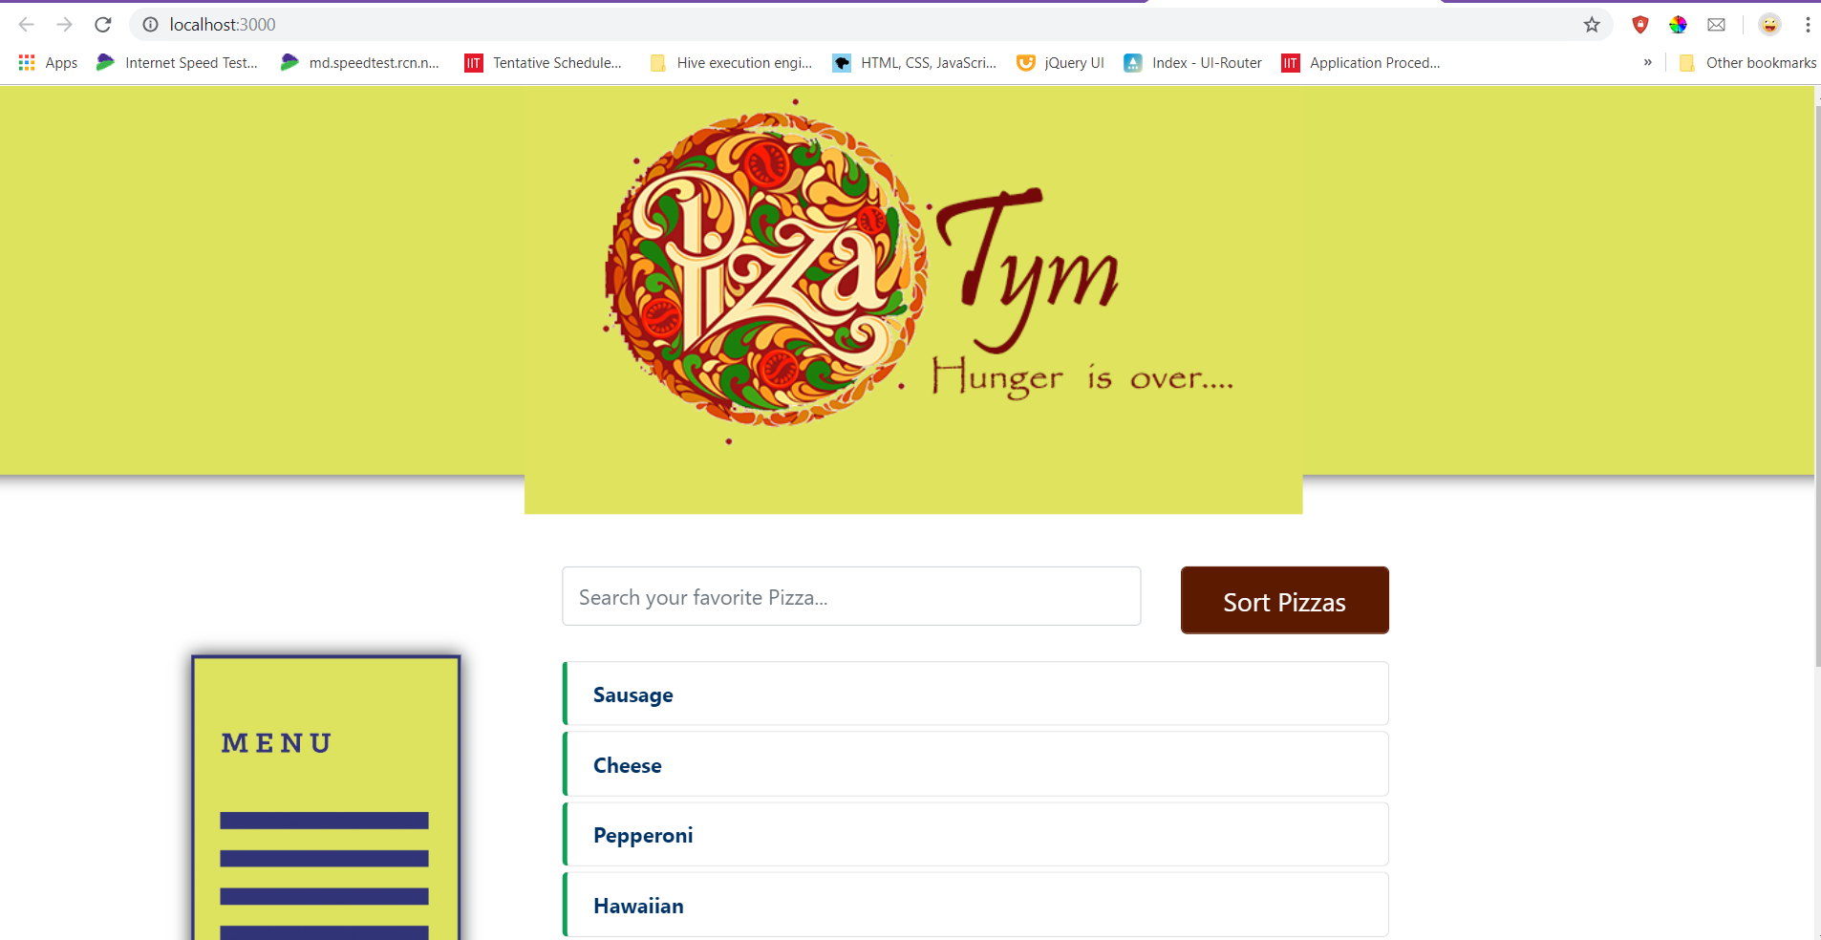

List of pizzas shown to user from server response

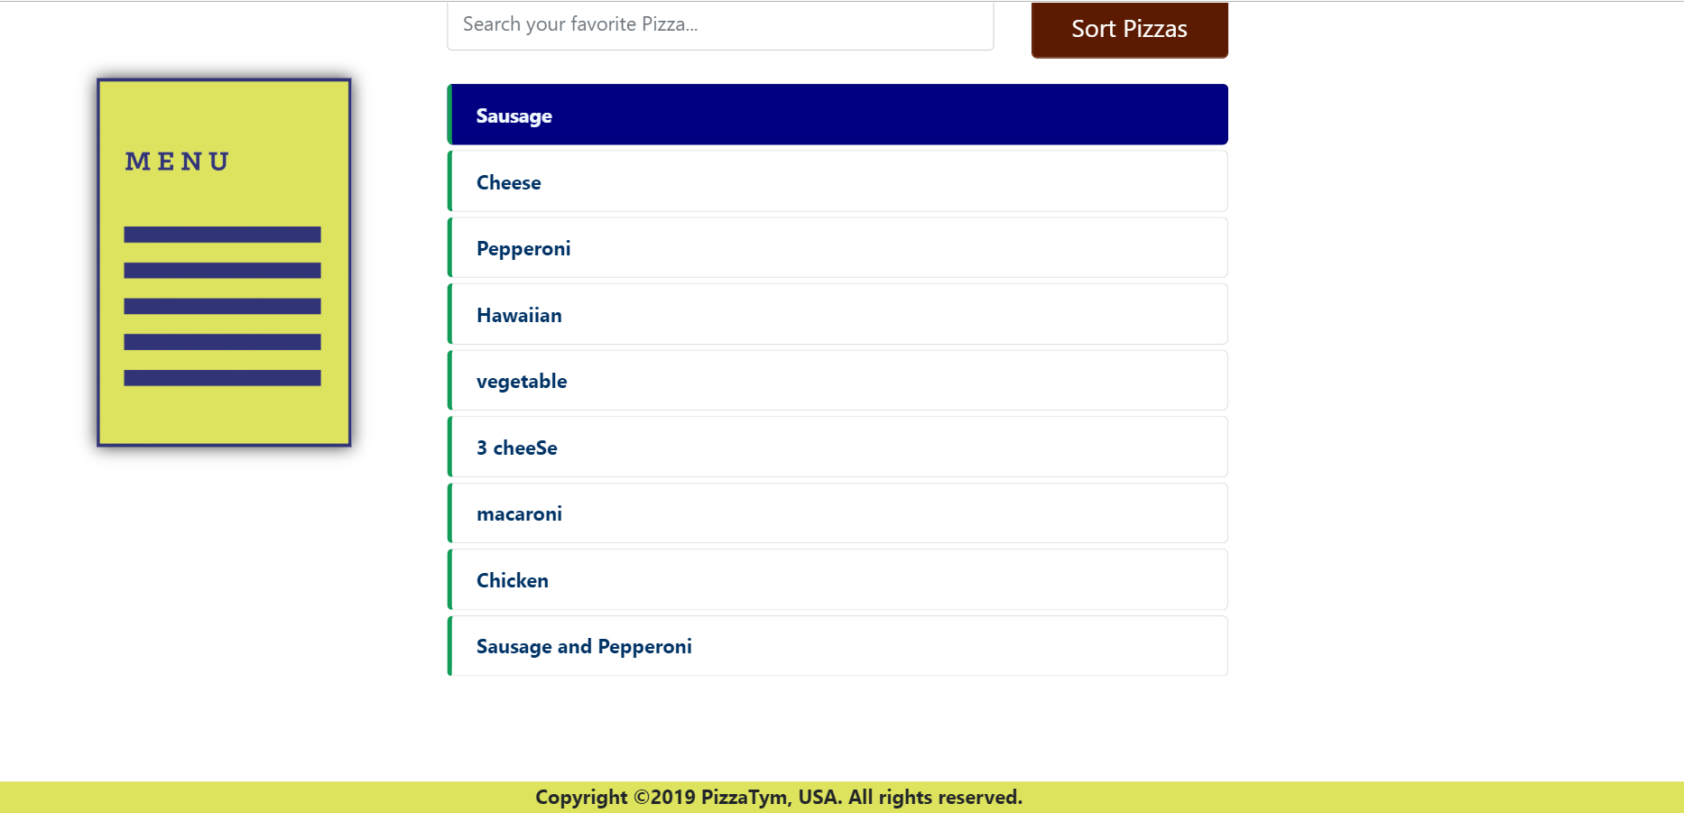

When page is loading and it is fetching data from URL, it shows “Loading data…” text.



Sorting List of original server response:

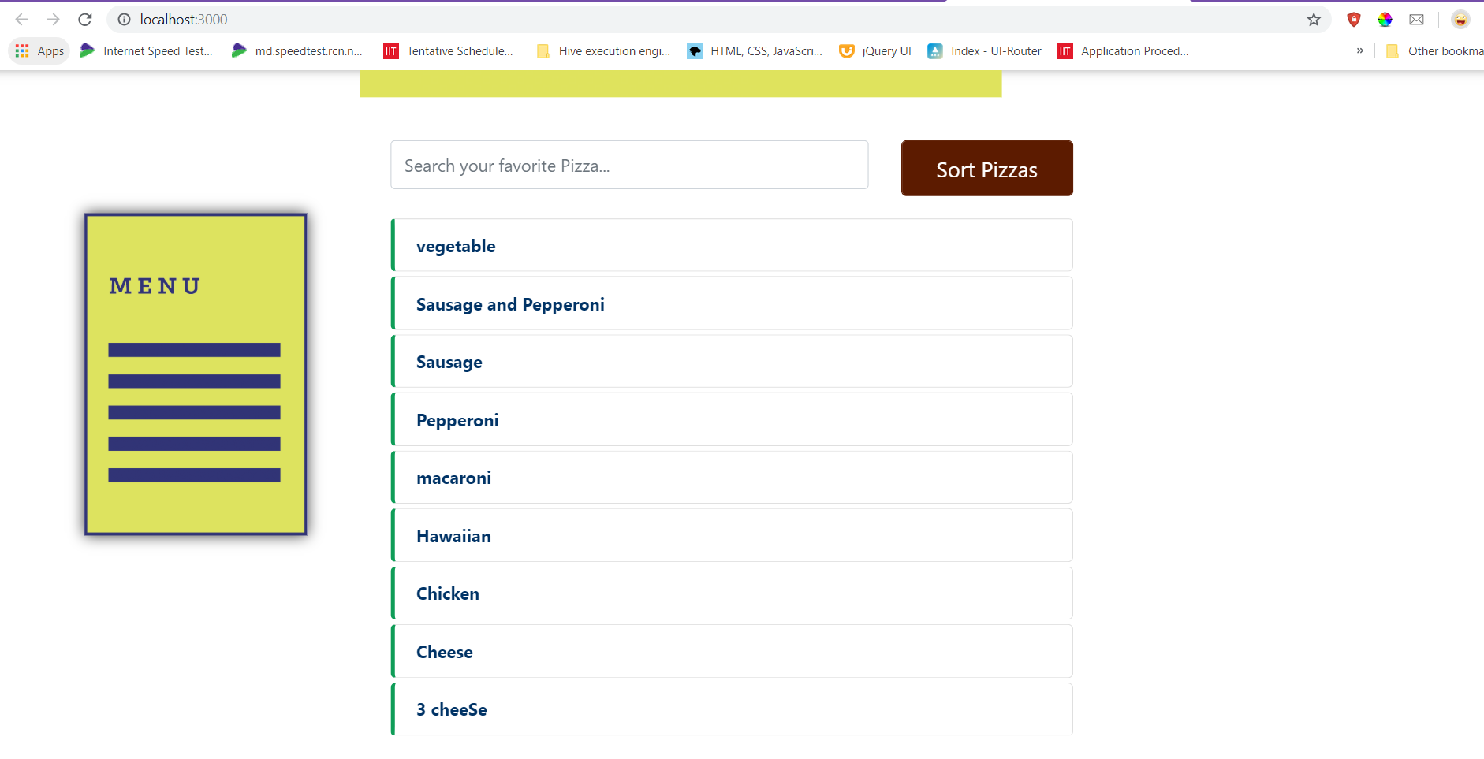

Filtering using User’s input:

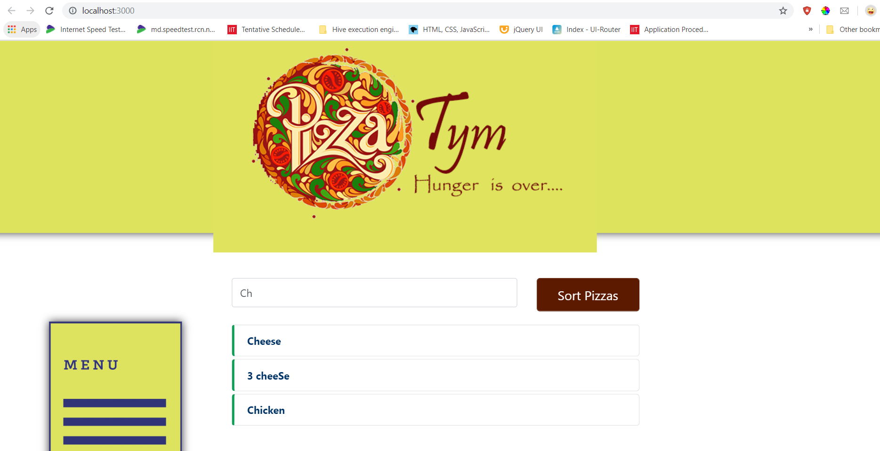

Sorting list of pizzas when user has entered filter text:

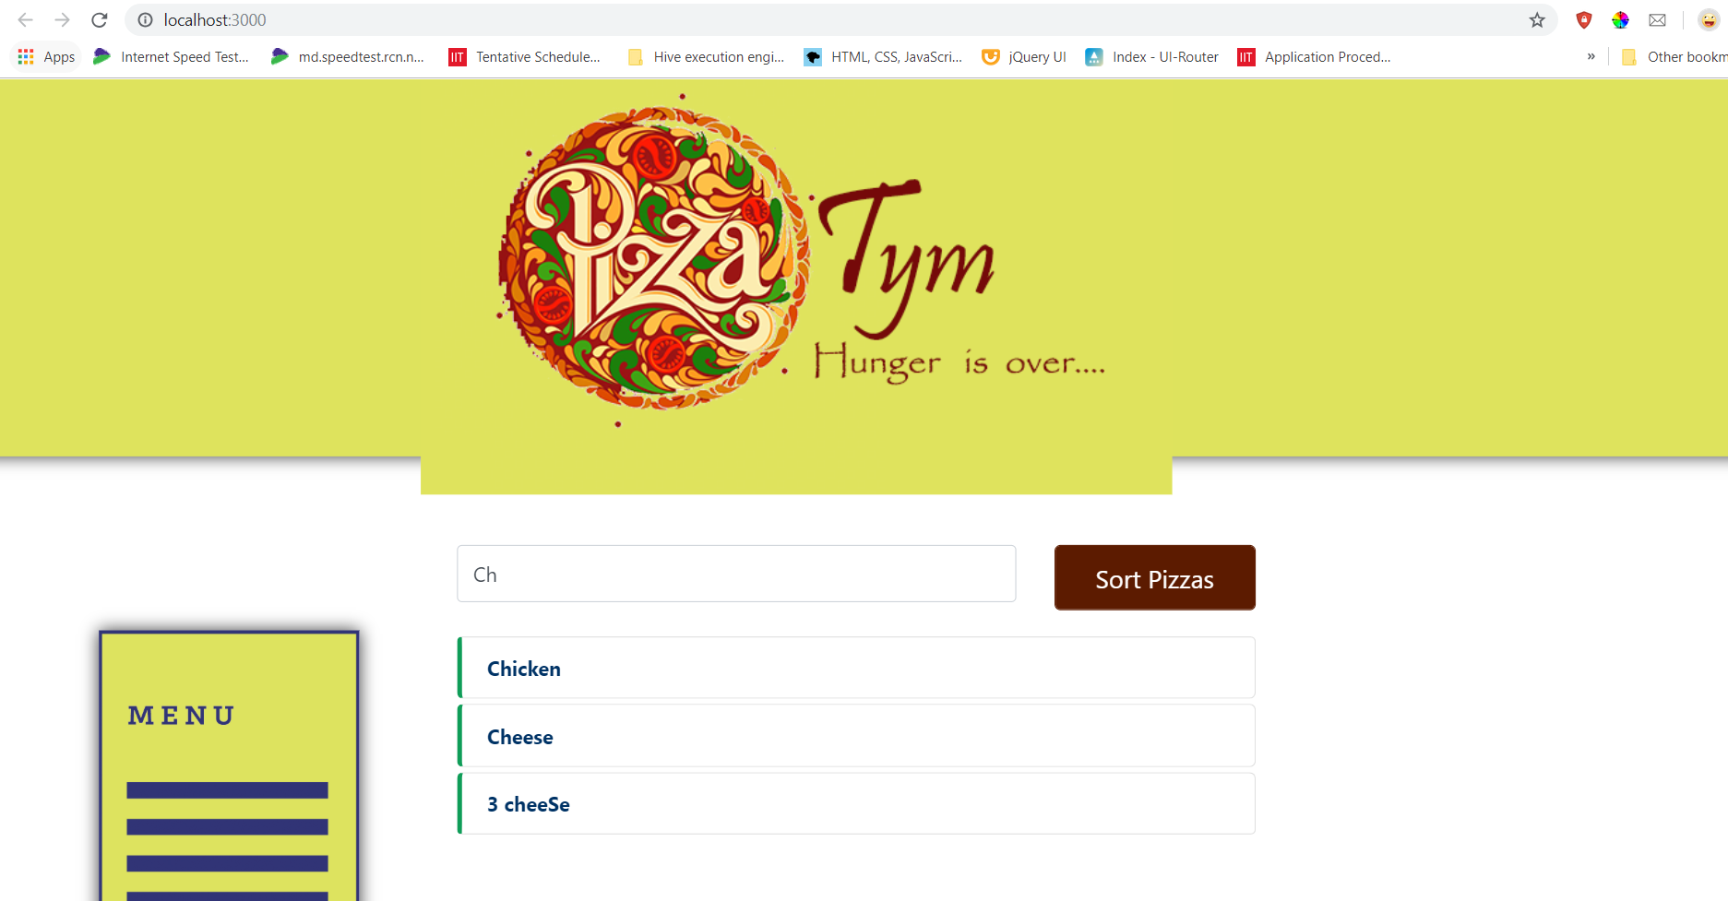

Case Insensitive filter search

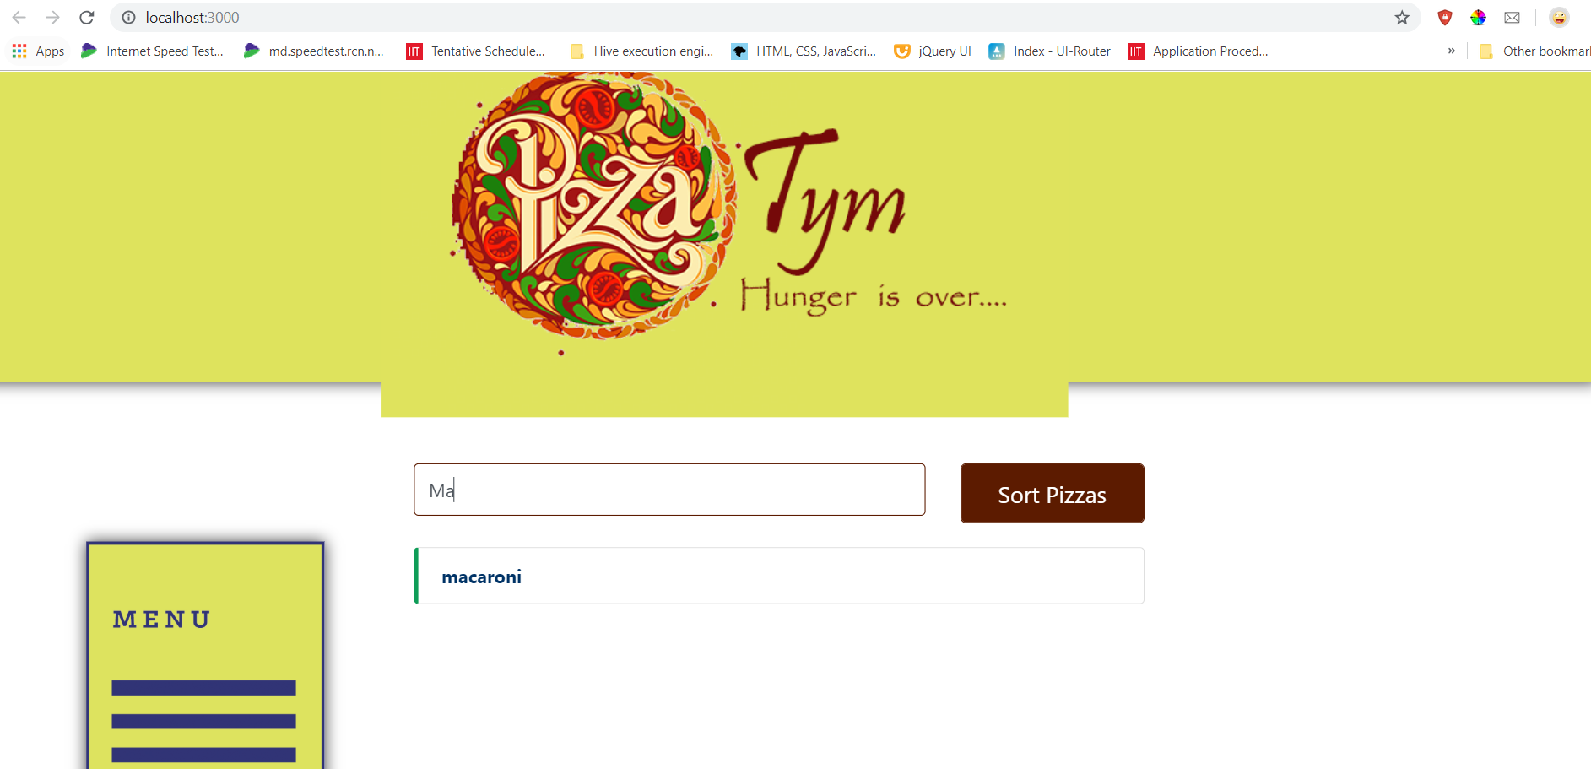

If no data is available

